Tutorial 1

- Describe the functions that should be provided by a modern full-scale multi-user DBMS.

- Describe the problems with the traditional two-tier client-server architecture and discuss how these problems were overcome with the three-tier client-server architecture.

- Describe the main characteristics of the database approach.
- Discuss the properties of a relational table.

5. What does a database expert mean when (s)he observes that a database displays both entity integrity and referential integrity?

- Discuss the differences between the candidate keys and the primary key of a table. Explain what is meant by a foreign key. How do foreign keys of tables relate to candidate keys? Give examples to illustrate your answer.

Use the database shown in Figure 1 to answer problems 7-10:

Figure 1

Table name: TRUCK Database name: CH2_TRUCK_CO
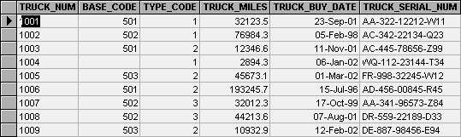

Table name: BASE
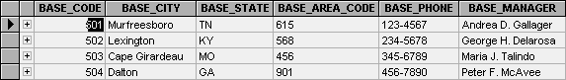

Table name: TYPE
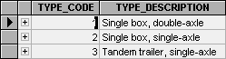

7. For each table, identify the primary key and the foreign key(s). If a table does not have a foreign key, write None in the assigned space.

Table Primary key Foreign Key(s)

TRUCK TRUCK_NUM TYPE_CODE
BASE BASE_CODE NONE
TYPE TYPE_CODE NONE

8. Do the tables exhibit entity integrity? Answer Yes or No, then explain your answer.

Table Entity Integrity? Explanation

TRUCK

BASE

TYPE

9. Do the tables exhibit referential integrity? Answer Yes or No, then explain your answer. Write NA (Not Applicable) if the table does not have a foreign key.

Table Referential Integrity? Explanation

TRUCK
BASE
TYPE

10. For each table, identify a super key.

Table Super key

TRUCK

BASE

TYPE

Use the database shown in Figure 2 to answer problems 11-13

FIGURE 2

Table name: PRODUCT Database name: CH2_P17
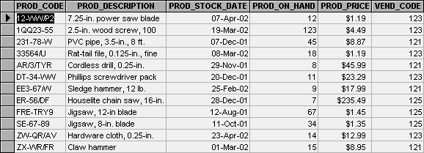

Table name: VENDOR
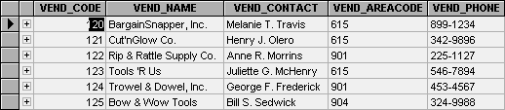

11. For each table, identify the primary key and the foreign key(s). If a table does not have a foreign key, write None in the assigned space.

Table Primary key Foreign Key(s)

PRODUCT
VENDOR

12. Do the tables exhibit entity integrity? Answer Yes or No, then explain your answer.

Table Entity Integrity? Explanation

PRODUCT
VENDOR

13. Do the tables exhibit referential integrity? Answer Yes or No, then explain your answer. Write NA (Not Applicable) if the table does not have a foreign key.

Table Referential Integrity? Explanation

PRODUCT

VENDOR

